Experiment - 4
Operating Systems Lab
Syeda Reeha Quasar
14114802719
6C7
AIM
To write the following shell programs:
- Program to check the given input is number or a string.
- Program to compute no. of characters/ words in each line of a file.

EXPERIMENT – 4

Aim:
To write the following shell programs:
- Program to check the given input is a number or a string.
- Program to compute no. of characters/ words in each line of a file.

Source Code:

The program to check the given input is a number or a string.:

echo "Program to find input is a string or a number"
echo "Enter the input to check: "
read n
echo "Given input is: "
if [[ $n =~ ^[0-9]*$ ]]
then
echo "It's number"
else
echo "Is a String"
fi

Output:

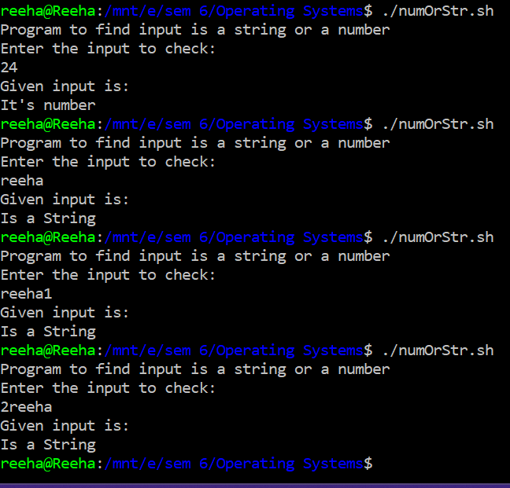
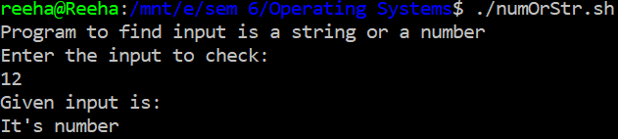
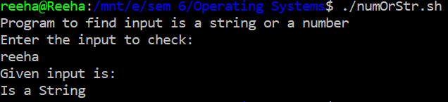

Program to compute no. of characters/ words in each line of a file:

echo "Enter the filename"
read file
c=`cat $file | wc -c`
w=`cat $file | wc -w`
l=`grep -c "." $file`
echo Number of characters in $file is $c
echo Number of words in $file is $w
echo Number of lines in $file is $l

Output:

